CS 353-Project Proposal

Mehmet Ege Acıcan 21602186

Koray Gürses

Gülnihal Muslu

Can Ozan Kaş

Part A) Description of the System

Our team proposes a Company Interview and Review Platform. A system similar to the Glassdoor job finding website or LinkedIn resue website. With the help of our platform, users would be able to search and apply for a specific job and the companies would be able to hire or refuse specific users for themselves. Users are also able to share their informations about themselves and they are able tos hare their resume in the platform as well. Along with the users, the companies will also have their own “resume”, based on the reviews of the users. However, specific reviews can be removed by the admins if the admin accepts the request made by the company. So, basically this platform is an online Company and Employee review platform that allows the users and companies to choose a specific job, specific person(Companies can do this) for application and acception. Along with this, it is also a resume (Person and Company) sharing platform.

A platform like this would definitely need a databasesystem because the whole platform works by reviewing the kept information of the companies accounts and the employee’s accounts. The information number can also be quite large( Considering the companies will hire users with more experience, more awards and more skills just as the users would prefer to apply for companies with more connections, more successes and more job offerings. Therefore, a simple program written in a specific High Level language may not be enough to keep all those data and change them whenever it is necessary.

Part b) Conceptual Design: E/R Diagram

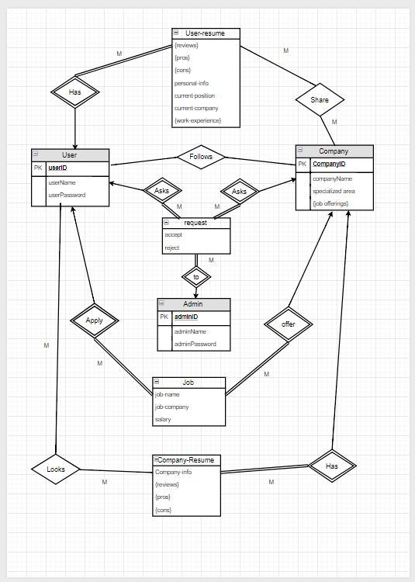

Notes about Entities and Relations:

Two users or two companies can have the same password. Only ID’s allow the uniqueness.

Even though, a job can exist without an employer, it must be found as soon as possible therefore making the user obligatory for Job.

The reviews of a certain company will be on the user’s resume. Thus, a user will share the review of a company through his/her resume. Therefore, it can be thought that a user’s resume will share the company reviews.

Part c) Logical Design

User(userID,userName,userPassword)

Company(companyID,companyName,specializedArea,jobOfferings)

Follows(userID, companyID)

Admin(adminID,adminName,adminPassword)

RequestUser(userID, adminID,accept,reject)

RequestCompany(companyID, adminID,accept,reject)

User-resume(userID, personal-info,reviews,pros,cons, currentPos,currentCompany,work-experience)

Company-resume(companyID, company-info ,reviews,pros,cons)

Job(userID, companyID,job-name,job-company,salary)

Looks(userID,company-info)

Share(userID,companyID,personal-info,reviews,pros,cons,current-pos,current-comp,work-experience,anonymous)